UGANDA AGRICULTURAL AGGREGATION PLATFORM

Functional Requirements Document (FRD)

Prepared by: E&M Technology House Ltd

DOCUMENT CONTROL
Project Name | Uganda Agricultural Aggregation Platform (UGAAP)
Document Type | Functional Requirements Document (FRD) / Functional Specification Document (FSD)
Version | 1.0
Derived From | UGAAP-BRD
Issue Date | April 2026
Document Owner | E&M Technology House Ltd
Approved By | TBD

Table of Contents
1. Purpose and Scope 4
1.1 Purpose of this Document 4
1.2 Background 4
1.3 In Scope 4
1.4 Out of Scope 4
1.5 Intended Audience 4
2. System Overview 5
2.1 Platform Components 5
2.2 Actor Summary 5
2.3 Key Business Rules 6
3. Module 1: Configuration Management 7
4. Module 2: User Management 9
5. Module 3: Onboarding Module 9
6. Module 4: Inventory Management 13
7. Module 5: Collection Management 16
8. Module 6: Finance 18
8. Module 7: Reporting 21
9. Module 8: Notifications 23
10. Module 9: Security and Access Control 24
11. Non-Functional Requirements 26
12. Conceptual Data Model 28
13. External Interface Specifications 31
14. Representative User Stories with Acceptance Criteria 32
15. Assumptions, Constraints, and Dependencies 34
16. Requirements Traceability Matrix 35

1. Purpose and Scope

1.1 Purpose of this Document
This Functional Requirements Document (FRD), also referred to as the Functional Specification Document (FSD), translates the business requirements defined in UGAAP-BRD into precise, testable functional specifications for the Uganda Agricultural Aggregation Platform. It provides the definitive reference for design, development, testing, and acceptance of the UGAAP system.

1.2 Background
Smallholder farmers account for approximately 80% of Uganda's agricultural output (FAO, 2018). Despite this dominance, cooperative-level aggregation remains hindered by paper-based processes, reconciliation backlogs lasting weeks, and a lack of real-time financial visibility. UGAAP digitizes the end-to-end agricultural value chain from farmer onboarding and input issuance through produce delivery, quality grading, balance calculation, and payment reconciliation replacing fragmented ledgers with a centralised, auditable digital platform.

1.3 In Scope
The following functional modules are specified in this document:
- Module 1: Agri-value chain Management
- Module 2: Collection Management
- Module 3: Inventory Management
- Module 4: Collection Management
- Module 5: Finance Management
- Module 6: User Management
- Module 7: Reporting
- Module 8: Notifications
- Module 9: Security and Access Control

1.4 Out of Scope
The following items are explicitly excluded from this version of the FRD:
- Direct payment disbursement to farmers (platform tracks obligations only; execution is external)
- Web scraping, market price feeds, or third-party commodity exchange integrations
- Loan origination or credit scoring beyond cooperative input credit tracking

1.5 Intended Audience
This document is intended for: Solution Architects, Software Developers, Quality Assurance Engineers, Business Analysts, Cooperative stakeholders validating functional coverage, and Project Managers tracking delivery scope.

2. System Overview

2.1 Platform Components
UGAAP is delivered as a multi-tenant, cloud-hosted platform comprising three primary channel components and a shared services layer
- Web Portal (Browser-based). Used by Platform admins, Cooperative Admins, and Branch Managers for configuration, reporting, and oversight.
- Android Mobile App. Used by Field Agents at collection points for farmer check-in, delivery recording, and quality assessment and by farmers for their day to day operations.
- USSD Interface. Accessible by farmers on any feature phone via MTN Uganda or Airtel Uganda networks for balance enquiries and dispute initiation.
- SMS Notification Engine. Dispatches event-driven and scheduled SMS notifications to farmers and operational staff.

2.2 Actor Summary
Actor (Configurable) | Channel | Primary Responsibilities (Configurable) | Data Scope
Actor 1: Platform Admin | Web Portal | System configuration, role management, sandbox, global reporting | All cooperatives
Actor 2: Cooperative Admin | Web Portal | Cooperative configuration, branch setup, season management, cross-branch reporting, onboarding approvals | Own cooperative
Actor 3:  Branch Manager | Web Portal, App | Farmer onboarding, delivery oversight, branch reports | Own branch only
Actor 4:  Field Agent | Android App | Farmer check-in, delivery recording, quality capture, input issuance | Own branch only
Actor 5:  Farmer | USSD, SMS | Balance enquiry, dispute initiation, receive notifications | Own records only

Disclaimer: All the actors and their primary responsibilities (roles and permissions) are configurable and are not predefined.

2.3 Key Business Rules
- No direct payment disbursement occurs within the platform. All payment amounts represent outstanding obligations only.
- All deduction logic, repayment schedules, and fee structures are parameter-driven and configurable per commodity, season, and branch.
- Branch data isolation is enforced at the database level. Branch Managers and farmers see only their branch's data.
- All financial figures and configuration changes generate immutable audit log entries.
- Organisational hierarchy in v1.0: Cooperative → Branch (no Region tier).

3. Module 1: Configuration Management
The Configuration Module is the administrative foundation of UGAAP. It enables Platform Admins and Cooperative Admins to define and maintain all operational parameters commodities, seasons, grading standards, repayment schedules, fees, roles, and notification templates without requiring code changes or system downtime.

FRD-ID | Feature / Function | Detailed Specification | Priority
FRD-CM-01 | Agriculture Value Chain | The system shall be to create configurable crop management and livestock management types | Must Have
FRD-CM-02 | Stock Item Type Management | The system shall allow Admin to configure non-crop, non-livestock stock items (e.g., jerry cans, seed bags) including item name, unit, value per unit, and repayment schedule reference. Items shall appear in the Input Catalogue immediately upon activation. | Must Have
FRD-CM-03 | Season Configuration | The system shall provide a Season Setup wizard with: season name, start date, end date, minimum and maximum price thresholds per commodity, target volume (tonnes), active commodity list, and active branch list. Seasons shall have states: Draft, Active, Closed. Only one season may be Active per commodity-branch combination. | Must Have
FRD-CM-04 | Grading Standards Configuration | The system shall allow Admin to define grading tiers per commodity (e.g., Grade A/B/C) with: quality parameter names, acceptable range (min/max), breach action (downgrade/reject), and price differential (UGX or %). The grading engine (FRD-DM-06) shall consume these tiers at runtime. | Must Have
FRD-CM-05 | Repayment Schedule Configuration | The system shall support repayment rule templates specifying: deduction percentage per delivery, installment count, grace period (days), and application scope (crop / livestock / stock). Rules shall be assignable to individual input issuance records. | Must Have
FRD-CM-06 | Deduction | The system shall maintain and have one-time deductions, regular deductions and any allowances | Must Have
FRD-CM-07 | Notification Template Management | The system shall provide a template editor supporting SMS and in-app templates with variable placeholders. Templates shall be versioned; only Active templates are dispatched by the notification engine. | Must Have
FRD-CM-08 | Role and Permission Configuration | The system shall support RBAC (Role-Based Access Control). Admin may CREATE roles (e.g., Branch Manager, Cooperative Admin), assign or revoke granular permissions per module and per action (View / Create / Edit / Approve / Delete). Permission matrix shall be exportable as PDF. | Must Have

4. Module 2: User Management
The User Management Module provides the administrative foundation for managing all human actors interacting with the UGAAP platform. It covers the full lifecycle of user accounts from creation and role assignment through to deactivation and audit, and implements the Role-Based Access Control (RBAC) framework referenced across all other UGAAP modules.
The table below defines the primary system roles shipped with UGAAP. All roles are configurable by the Platform Admin except the Farmer role, which is system-managed. Additional custom roles may be created via FRD-UM-04.

Feature / Function | Detailed Specification | Priority
User Creation | Full access to all modules, system configuration, global reporting | Yes
User Approval | Cooperative config, branch setup, season management, cross-branch read, report download | Yes
Role Assignment | Farmer onboarding approval, delivery oversight, input issuance approval, branch reports, correction approval | Yes
Own branch only | Farmer check-in, delivery recording, quality capture, input issuance recording | Yes
Own records only | USSD balance enquiry, dispute initiation, receive SMS/in-app notifications | No

5. Module 3: Onboarding Module
The Onboarding Module manages the end-to-end registration and activation journey for cooperatives (as tenants) and individual farmers (as platform users). It enforces a configurable multi-stage pipeline with SLA tracking, automated communications, and bulk upload capability.

FRD-ID | Feature / Function | Detailed Specification | Priority
FRD-OB-01 | Multi-Stage Onboarding Workflow | The system shall implement a configurable onboarding pipeline with named stages: (1) Pre-Registration, (2) KYC Data Capture, (3) Profile Completion, (4) Document Verification, (5) Group Assignment, (6) Credit Assessment, (7) Activation. Stage transitions shall require explicit approval or system rule satisfaction. Admin may add, rename, or reorder stages without code change. | Must Have
FRD-OB-02 | Farmer Profile Data Capture | The onboarding form shall capture: national ID number, full name, date of birth, gender, phone number (primary + secondary), GPS coordinates of farm, farm size (acres), crops cultivated, branch assignment, and group assignment. All mandatory fields shall be validated before stage progression. | Must Have
FRD-OB-03 | Document Upload and Verification | The system shall allow upload of scanned national ID, tenant existing information (JPEG/PNG/PDF,XLS max 5 MB each). Document verification officers shall receive a task to review and Accept or Reject with comments. Rejections trigger SMS to farmers requesting re-submission. | Must Have
FRD-OB-04 | Bulk Farmer Upload | Admin and Branch Managers shall upload farmer records via a CSV or Excel template. The system shall validate: required field presence, phone number format, branch code validity, and duplicate national ID. A Validation Report shall list row-level errors before import confirmation. Valid rows import; invalid rows are flagged for manual correction. | Must Have
FRD-OB-05 | Onboarding Communications | At each stage transition, the system shall send an automated SMS to the farmer's primary number using the relevant notification template. In-app notifications shall also be dispatched to the assigned Branch Manager. | Must Have
FRD-OB-06 | Re-activation Workflow | Deactivated farmers may be reactivated through a configurable workflow requiring: reason for reactivation, re-verification of contact details, and Branch Manager approval. Reactivation restores full access to delivery and input modules. | Must Have
FRD-OB-07 | Cooperative Onboarding | The system shall support onboarding of cooperatives as tenants. Cooperative onboarding includes: cooperative name, registration number, address, contact person, branch configuration, and initial admin user creation. | Must Have
FRD-OB-8 | Group / Cluster Management | The system shall allow creation of farmer groups within a branch. Groups carry: group name, group leader (farmer ID), and member list. Group-level aggregation shall be available in reports and dashboards. | Should Have

Cooperative Onboarding
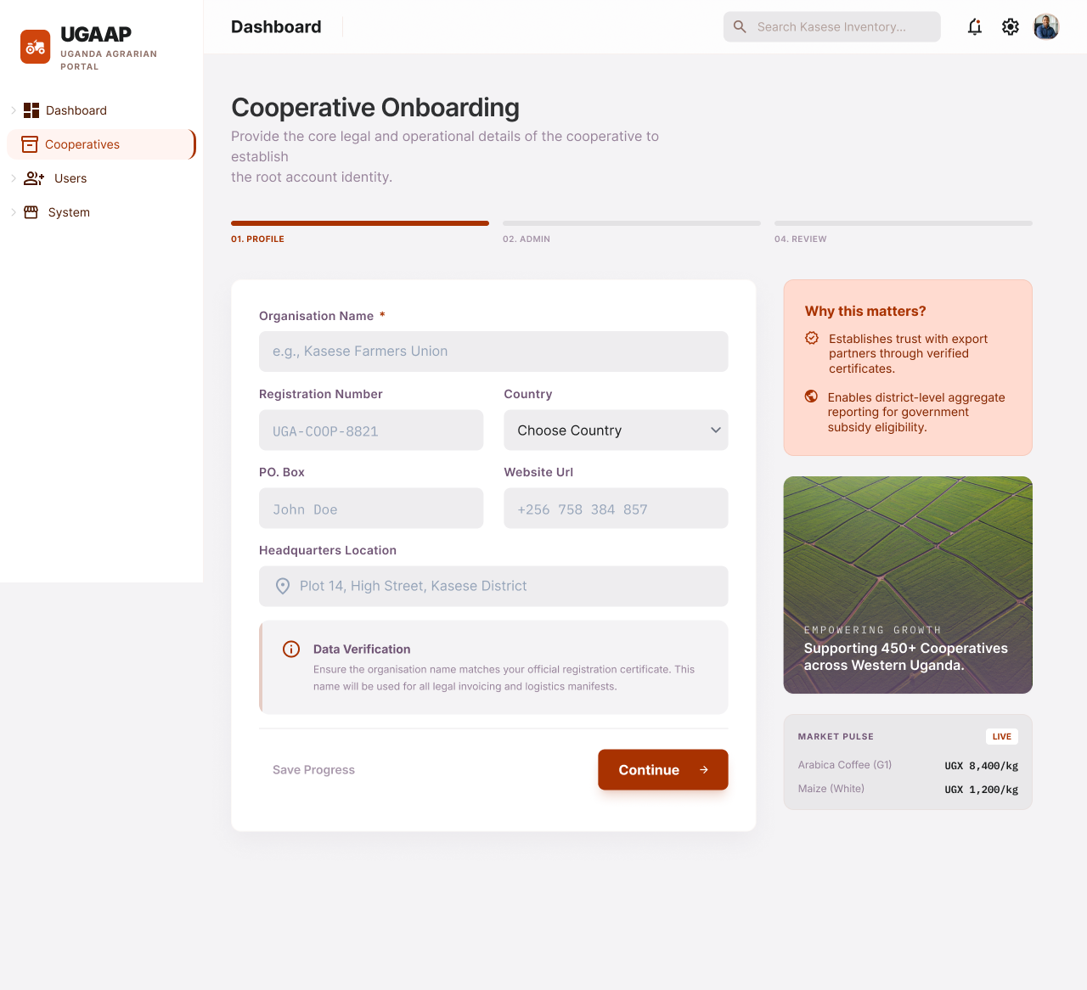

6. Module 4: Inventory Management
The Inventory Management Module tracks all resources issued to farmers by the cooperative crop inputs (seeds, fertiliser, agrochemicals), livestock, and stock items and maintains real-time per-farmer credit ledgers recording outstanding repayments.

FRD-ID | Feature / Function | Detailed Specification | Priority
FRD-IM-01 | Input Catalogue | The system shall maintain an Input Catalogue listing all active input types (crops, livestock, stock items) with: name, category, unit, current unit value, and linked repayment rule. Catalogue entries are managed through the Configuration Module (FRD-CM-01 to FRD-CM-03). | Must Have
FRD-IM-02 | Input Issuance Recording | Branch agents shall record input issuances per farmer capturing: input type, quantity, unit value, total value (auto-calculated), issuing date, issuing agent, season reference, and repayment rule applied. Each issuance generates a unique Input Record ID. | Must Have
FRD-IM-03 | Input Credit Ledger | The system shall maintain a per-farmer Input Credit Ledger storing: all issuance records, cumulative outstanding balance (UGX), credit limit (configurable per branch), and balance history with timestamps. The ledger shall update in real time upon each issuance or repayment event. | Must Have
FRD-IM-04 | Stock Item Tracking | Non-crop stock items shall be tracked from distribution through recovery. The system maintains: item type, quantity issued, quantity recovered, outstanding balance (units and UGX), and recovery date. | Must Have
FRD-IM-05 | Repayment Recording | Repayment events (cash, produce offset, or livestock return) shall be recorded against the specific Input Record. Each repayment entry captures: repayment date, amount (UGX or units), repayment type, recorded-by agent, and updated outstanding balance. Repayments automatically update the Input Credit Ledger. | Must Have
FRD-IM-06 | Outstanding Balance Calculation | The system shall record per-farmer outstanding input balance in real time as. This balance is visible to Branch Manager and Admin. Farmers receive their balance via SMS/App on request or at configured trigger points. | Must Have
FRD-IM-07 | Input Reports Export | The system shall generate downloadable reports showing: inputs issued (by type/branch/season), repayments made, outstanding balances, and overdue accounts. Export formats: Excel (.xlsx) and PDF. | Must Have
FRD-IM-08 | Overdue Credit Alerts | The system shall flag farmers whose outstanding input balance exceeds a configurable threshold within a configurable number of days before season-end. Alerts are sent via SMS/App to the farmer and in-app notification to the Branch Manager. | Must Have
FRD-IM-09 | Farmer Check-In | The web based portal shall support three farmer identification methods at delivery check-in: (1) manual name/ID search, (2) manual name/ID search. Upon identification, the farmer's profile and outstanding balance are displayed to the agent. | Must Have
FRD-IM-10 | Dispute Management | Farmers shall be able to raise a payment dispute via USSD or Branch Manager on their behalf. Each dispute captures: delivery record reference, disputed parameter, farmer's claimed value, and evidence notes. | Must Have

Inventory Management

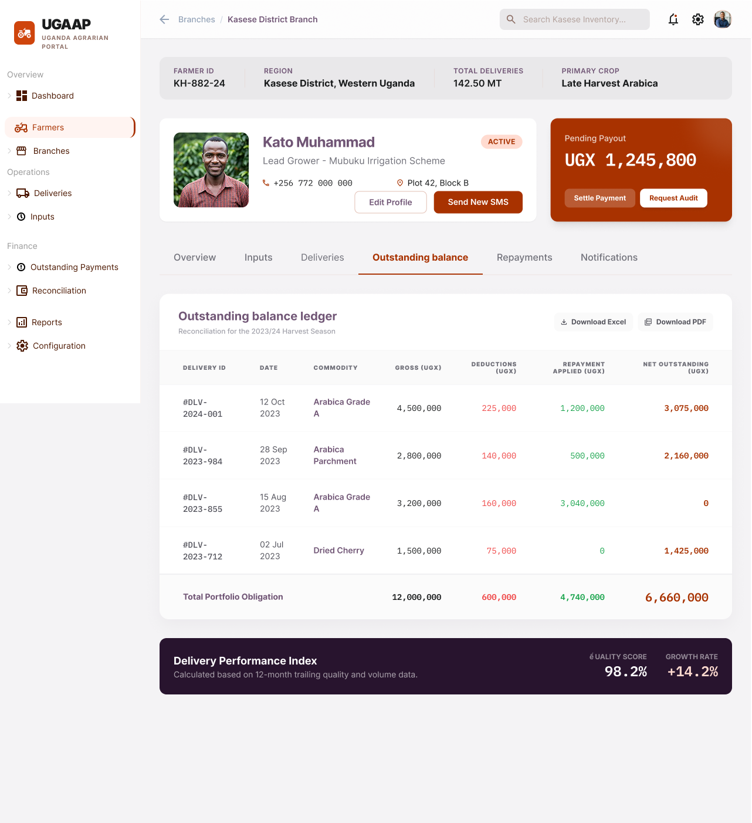

7. Module 5: Collection Management
Collection Management module enables field agents to capture produce deliveries at collection points or different cooperative branches integrating with digital weighbridges and supporting full offline operation. Every delivery record flows directly into quality recording and payment calculation and also includes a grading element that captures commodity grade parameters at point of delivery, and applies the configured grading engine to automatically assign grades and record price accordingly.

FRD-ID | Feature / Function | Detailed Specification | Priority
FRD-CM-01 | Delivery Recording | The system shall capture: any related metadata about the delivered products | Must Have
FRD-CM-02 | Weighbridge Integration | The system shall integrate with digital weighbridges via Bluetooth or serial interface to auto-populate gross weight. If the weighbridge is unavailable, the agent may enter weight manually; manual entries require supervisor approval before finalisation. | Must Have
FRD-CM-03 | Delivery Receipt Notification | Upon successful delivery recording, the system shall send an SMS to the farmer containing: all the information about the produce | Must Have
FRD-CM-04 | Delivery Collection Workflow | Collections to recorded deliveries require: reason code selection, supervisor (Branch Manager) approval, and full audit trail (original value, corrected value, approver, timestamp). Corrections trigger a revised SMS to the farmer. | Must Have
FRD-CM-05 | Batch Management | The system shall group delivery records into processing batches based on configurable rules | Must Have
FRD-CM-06 | Offline Delivery Recording | The system shall use USSD/App for offline capabilities | Must Have
FRD-CM-07 | Quality Parameter Capture | The system shall record quality parameters per delivery as configured in the Grading Standards. | Must Have
FRD-CM-08 | Automated Grading Engine | Upon parameter capture, the system shall automatically: compare each parameter against configured tier thresholds, assign the appropriate grade (e.g., Grade A, B, C, Reject), and calculate the price adjustment (UGX per kg differential). Grade and adjusted price are stored against the Delivery Record. | Must Have

8. Module 6: Finance
The Finance Module calculates outstanding payment amounts owed to each farmer following produce delivery and grading, applies all applicable deductions and input offsets, and maintains a real-time net balance ledger. The platform does not disburse payments; it produces reports for external payment execution.
FRD-ID | Feature / Function | Detailed Specification | Priority
FRD-PT-01 | Finance | - Open batch  - Deductions  - One time deductions  - Close batch  - Payment file generation | Must Have
FRD-PT-2 | Outstanding Payment recording | For each delivery record, the system shall record the outstanding payment amount and with the applicable deductions. Deductions are drawn from the configured Fee Catalogue (FRD-CM-07). | Must Have
FRD-PT-03 | Farmer Payment Ledger | A detailed per-farmer payment ledger shall record: each delivery's gross payment, all deduction line items (type, amount, date), input repayment offsets, and the resulting outstanding balance. Ledger is immutable once finalised for a season. | Must Have
FRD-PT-04 | Deduction Recording | Every deduction applied to a farmer's payment shall be recorded with: deduction type, amount (UGX), calculation basis, applied date, and authorising rule reference. Deduction records are visible to the farmer (via SMS summary) and auditable. | Must Have
FRD-PT-05 | Outstanding Payment Reports | The system shall generate downloadable Outstanding Payment Reports per branch, season, and commodity. | Must Have
FRD-PT-06 | Farmer Payment Notifications | The system shall notify farmers via SMS of their outstanding payment balance upon: delivery grading completion, reconciliation completion, and on-demand request via USSD. SMS content includes net weight, grade, gross amount, deductions, input offset, and net balance. | Must Have
FRD-PT-07 | No Direct Disbursement | The platform shall NOT disburse funds to farmers. All payment figures represent obligations and records only. Reports are downloaded by authorised Cooperative staff for execution through external payment channels. | Must Have

Payment Batches
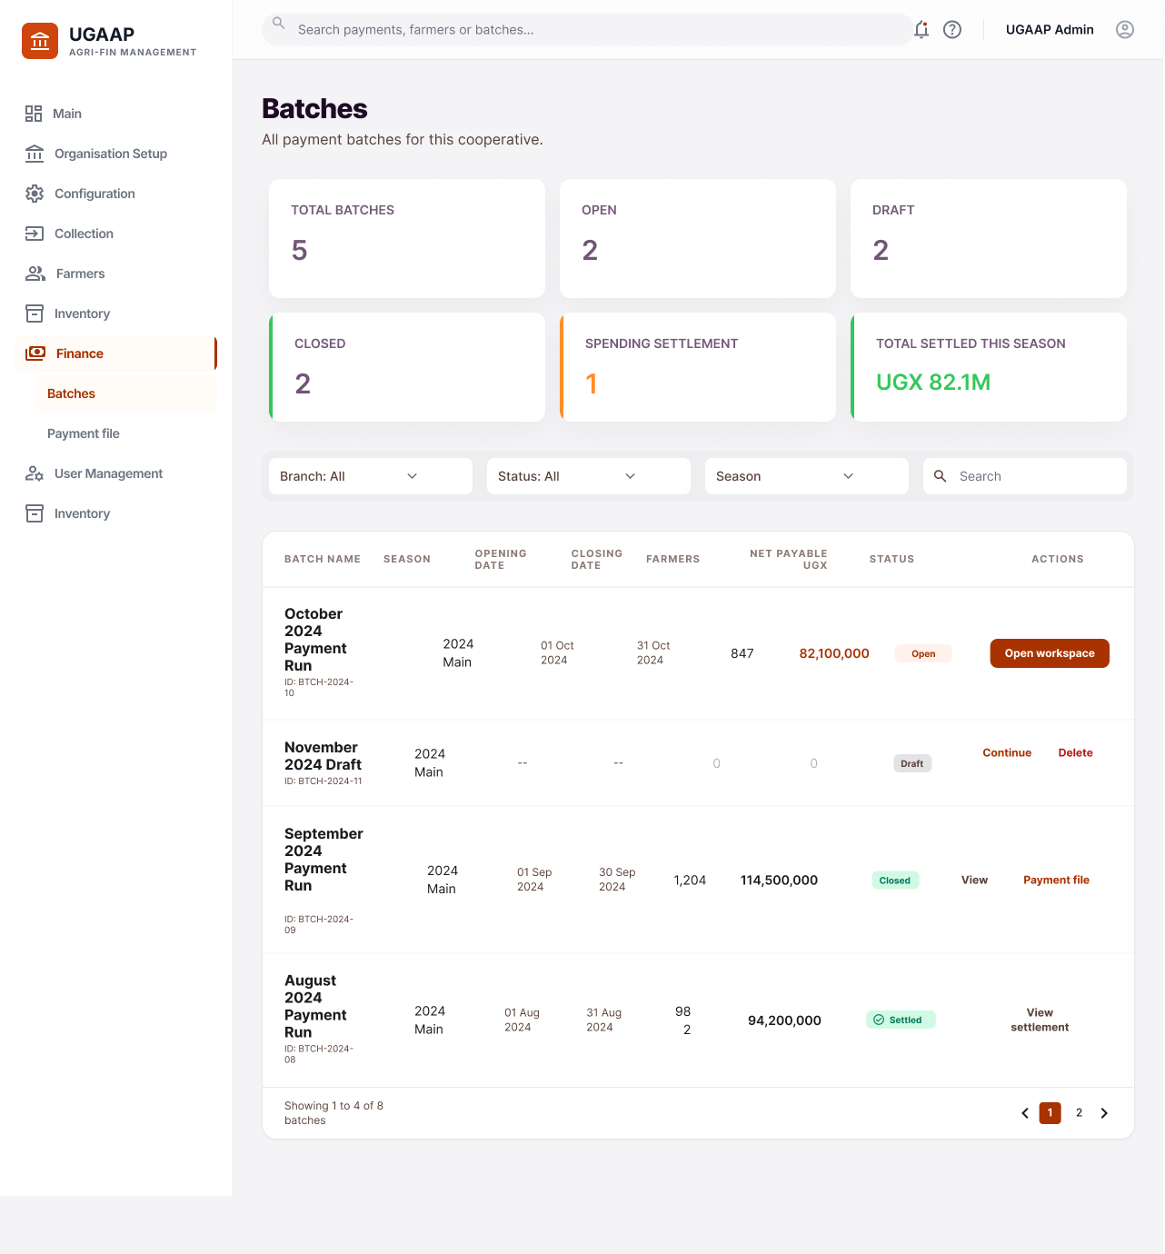

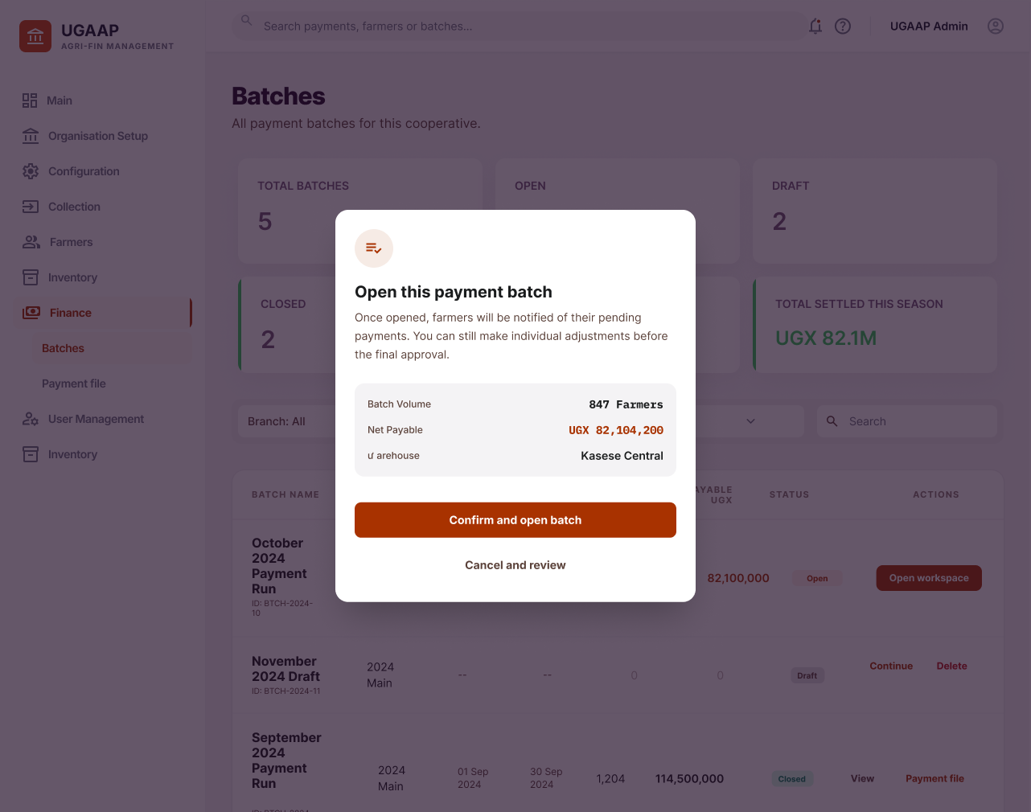

8. Module 7: Reporting
The Reporting Module provides a library of standard operational and financial reports, all exportable in Excel and PDF formats. Reports support multi-dimensional filtering, on-demand generation, and configurable scheduling.
FRD-ID | Feature / Function | Detailed Specification | Priority
FRD-RP-01 | Standard Report Library | The system shall provide a library of standard reports including: Farmer Input Summary, Delivery Register, Grading Summary, Outstanding Payments Report, Audit Log Export, Livestock Ledger Report, and Branch Performance Dashboard. | Must Have
FRD-RP-02 | Report Filtering | All reports shall support filters: branch, season, commodity type, date range, farmer group, and individual farmer ID. Filters are combinable. The applied filter set is displayed in report headers. | Must Have
FRD-RP-03 | Export Formats | Reports shall be exportable in Excel (.xlsx) and PDF. Excel exports include raw data with one row per record. PDF exports include formatted layouts with cooperative branding, page numbers, and generation timestamp. | Must Have
FRD-RP-04 | Scheduled Report Generation | Admin may schedule reports to generate automatically at configured intervals (daily, weekly, monthly) and deliver to specified email addresses or stores in the platform's report archive. | Should Have
FRD-RP-05 | On-Demand Report Generation | Users with Report permission may generate any available report on demand. | Must Have
FRD-RP-06 | Branch Performance Dashboard | A visual dashboard per branch showing: total farmers onboarded, active season metrics (deliveries, total weight, average grade), input outstanding balance total, payment outstanding total, and reconciliation status. | Should Have

Reports catalogue
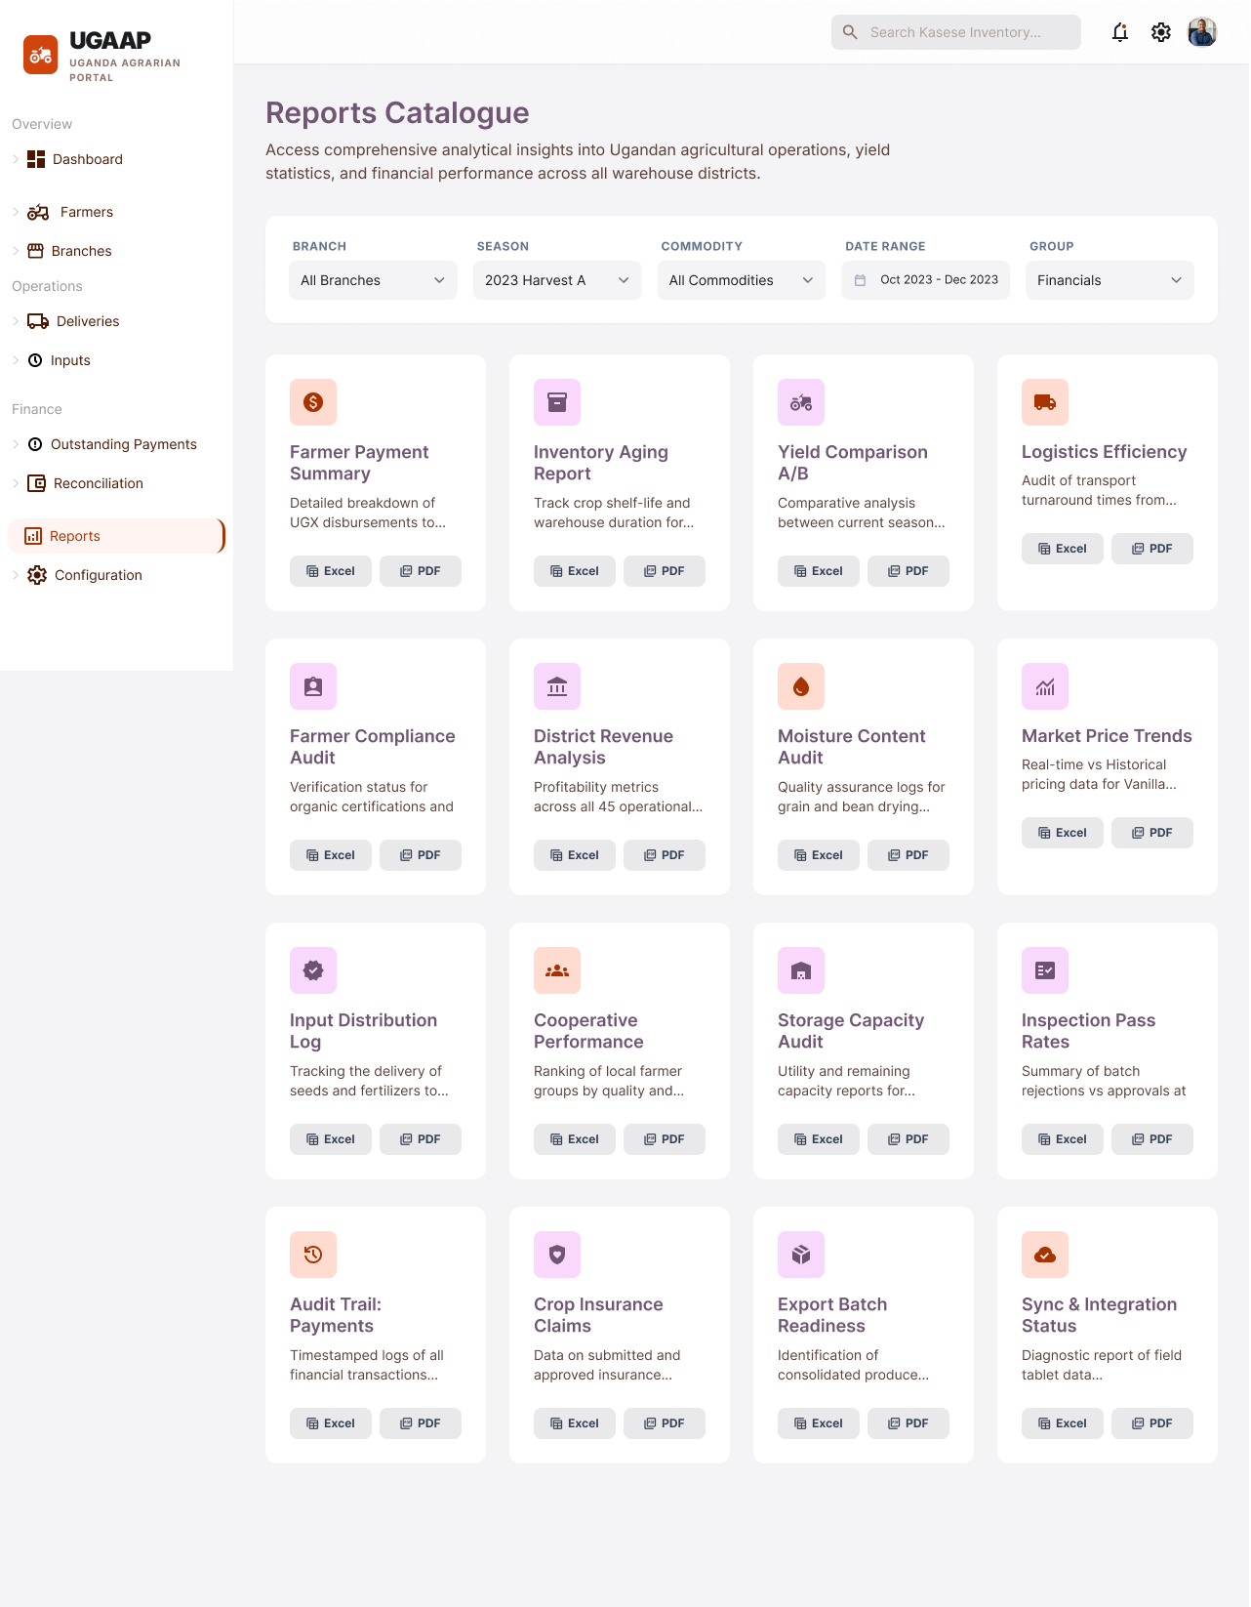

9. Module 8: Notifications
The Notifications Module drives all outbound communications, SMS to farmers, in-app alerts to operational staff, and email for scheduled reports via a configurable, event-driven notification engine backed by auditable delivery logs.

FRD-ID | Feature / Function | Detailed Specification | Priority
FRD-NT-01 | Event-Based SMS Notifications | The system shall dispatch SMS notifications on defined business events including: farmer onboarding stage change, input issuance recorded, delivery received, grade assigned, delivery rejected, outstanding balance updated, and reconciliation completed. | Must Have
FRD-NT-02 | Reminder Notifications | The system shall dispatch periodic SMS reminders for: outstanding input balances approaching season-end (configurable lead time), overdue livestock returns, and unresolved quality disputes. | Must Have
FRD-NT-03 | Approval / Maker-Checker Notifications | In-app notifications shall be generated for all pending approval actions: delivery corrections, document verifications, exception resolutions, and configuration promotions. Notifications include action required, deadline, and deep link to the relevant screen. | Must Have
FRD-NT-04 | Exception Alerts | Real-time alerts shall be dispatched to relevant role holders when: a reconciliation exception is created, a quality dispute is escalated, a weighbridge anomaly is detected, or a delivery correction is requested. Alert channels: in-app and email. | Must Have

10. Module 9: Security and Access Control
The Security Module specifies authentication, authorisation, data isolation, encryption, and audit logging requirements that apply platform-wide across all modules and all channel components.
FRD-ID | Feature / Function | Detailed Specification | Priority
FRD-SC-01 | Authentication (OAuth 2.0 + JWT) | The system shall implement OAuth 2.0 authorization with JWT bearer tokens for all API access. Token expiry shall be configurable | Must Have
FRD-SC-02 | Two-Factor Authentication | OTP-based 2FA (via SMS) shall be mandatory for: all administrative logins, all financial recording operations (input issuance, repayment recording, reconciliation upload), and configuration changes in production. | Must Have
FRD-SC-03 | Branch Data Isolation | The platform shall enforce branch-level data isolation at the database row level (Row Level Security). Branch Managers and farmers shall only access data belonging to their branch. Admin and Cooperative roles have cross-branch read access. Cross-branch data access shall be technically impossible without explicit role elevation. | Must Have
FRD-SC-04 | Immutable Audit Log | All user actions shall be written to an append-only audit log stored in a separate, access-restricted schema. Audit log records include: user ID, session ID, IP address, action type, affected entity, before-state, after-state, and timestamp. Log tampering shall be technically prevented. | Must Have
FRD-SC-05 | Data Encryption | All data in transit shall be encrypted using TLS 1.3. All PII and financial records at rest shall be encrypted using AES-256. | Must Have
FRD-SC-06 | Session Management | Inactive sessions shall auto-expire after a configurable timeout (default 20 minutes). Concurrent login detection shall flag and optionally terminate duplicate sessions. All session events are audit-logged. | Must Have

11. Non-Functional Requirements
The following non-functional requirements apply to the platform as a whole and supplement the functional specifications in Sections 3–13.
NFR-ID | Requirement | Specification | Category
NFR-01 | API Response Time | All critical user-facing API operations (delivery recording, balance queries, report fetching) must complete within 2 seconds at the 95th percentile under normal load. | Performance
NFR-02 | Concurrent User Support | The system must support concurrent authenticated users without performance degradation or data inconsistency. | Performance
NFR-03 | Peak Transaction Volume | The system must handle delivery transaction records per day during peak aggregation season. | Performance
NFR-04 | Report Generation Speed | Standard reports must be generated within seconds. | Performance
NFR-05 | System Uptime | System must be maintained during active aggregation sessions | Availability
NFR-07 | Disaster Recovery | RTO: 4 hours. RPO: 1 hour. Automatic failover to secondary region. DR tests conducted semi-annually. | Availability
NFR-08 | Data Encryption | TLS 1.3 for all data in transit. AES-256 for all PII and financial data at rest. | Security
NFR-09 | Authentication Standard | OAuth 2.0 with JWT. OTP 2FA mandatory for admin and financial operations. | Security
NFR-10 | Branch Data Isolation | Database-level row-level security enforced. Zero cross-branch data leakage is technically possible. | Security
NFR-11 | Regulatory Compliance | Compliant with Uganda Data Protection and Privacy Act 2019. ISO 27001 certification required. Pen test every 6 months. | Compliance
NFR-12 | Farmer Registry Scale | Registered farmers per tenant with no performance degradation on queries or reports. | Scalability
NFR-13 | Branch Scalability | Unlimited branches per tenant with independent data isolation per branch. | Scalability
NFR-14 | Commodity Configurability | Unlimited crop, livestock, and stock item types configurable without schema or code changes. | Scalability
NFR-15 | Tenant Provisioning | New cooperative tenants live within 72 hours via template-based provisioning. | Scalability
NFR-16 | Web Portal Accessibility | WCAG 2.1 AA compliance. Chrome, Firefox, Safari, Edge support. | Usability
NFR-17 | USSD Connectivity Requirements(Offline Access Alternative) | USSD functionality shall operate without requiring internet/data connectivity and must be accessible via GSM networks (2G/EDGE/3G) across all supported telecommunications providers. The system shall be optimized for low-bandwidth environments and provide reliable session handling under intermittent network conditions | Usability
NFR-18 | USSD Usability Requirements | USSD shall be operable on any GSM-supported feature phone and must be optimized for fast, simple user interactions within standard session time limits | Usability
NFR-19 | Audit Retention | Immutable audit log: indefinite retention. Transaction/delivery records: 10 years. Reconciliation records: 7 years. | Compliance

12. Conceptual Data Model
The following table defines the key entities, their primary attributes, and their relationships. This conceptual model is intended to guide physical database design; detailed entity-relationship diagrams are to be produced in the Technical Architecture Document.

Entity | Key Attributes | Relationships | Primary Key | Notes
Cooperative | Name, Reg No, Address, Admin User | Has many Branches, Has many Seasons | cooperative_id | Top-level tenant entity
Branch | Name, GPS, Branch Manager ID | Belongs to Cooperative; Has many Farmers | branch_id | Data isolation boundary
Farmer | NationalID, Name, Phone, GPS, FarmSize, Status | Belongs to Branch; Has many Deliveries, Input-Records | farmer_id | Soft-delete on deactivation
FarmerGroup | GroupName, Leader  FarmerID | Belongs to Branch; Has many Farmers | group_id | Optional cluster assignment
Season | Name, StartDate, EndDate, Status | Belongs to Cooperative; Active commodity list | season_id | One Active season per commodity-branch
CropType | Name, Unit, PriceBasis | Has many Grading-Tiers | crop_type_id | Config-driven; no schema change
LivestockType | Name, Unit, ValuePerUnit, RepayRule | Has many Livestock-  Issuances | livestock_type_id | Config-driven; no schema change
StockItemType | Name, Unit, ValuePerUnit, RepaySchedule | Has many Stock-Issuances | stock_item_type_id | Non-crop non-livestock assets
InputRecord | FarmerID, InputType, Qty, Value, RepayRule, Date | Belongs to Farmer & Season; Has many Repayments | input_record_id | Covers crop, livestock, stock
Repayment | InputRecordID, Amount, Type, Date, AgentID | Belongs to InputRecord | repayment_id | Type: cash/produce/livestock
Delivery  Record | FarmerID, CommodityID, GrossWt, TareWt, NetWt, Date, AgentID | Belongs to Farmer, Season, Batch; Has one Grade | delivery_id | Immutable after grading
GradeRecord | DeliveryID, Grade, AdjustedPrice, Parameters (JSON) | Belongs to DeliveryRecord | grade_id | Parameters stored as JSON
Deduction | DeliveryID, Type, Amount, Basis, Date | Belongs to DeliveryRecord | deduction_id | References DeductionCatalogue
FarmerBalance  Ledger | FarmerID, SeasonID, GrossPay, TotalDeductions, InputOffset, NetBalance | Belongs to Farmer, Season | ledger_id | Recalculated on each event
Reconciliation  Upload | FileRef, UploadedBy, UploadDate, Status | Has many Reconciliation  Rows | recon_upload_id | Status: Pending/Matched/Exceptions
Reconciliation  Row | UploadID, FarmerID, Amount, MatchStatus, ExceptionType | Belongs to Reconciliation  Upload | recon_row_id | MatchStatus: Exact/Partial/None
Audit Log | UserID, Action, EntityType, EntityID, Before(JSON), After(JSON), Timestamp | Immutable; references all entities | audit_id | Append-only
Notification  Log | RecipientID, Channel, Template, Status, Timestamp | Belongs to triggering entity | notif_id | SMS/in-app/email

13. External Interface Specifications
The following interfaces are required for UGAAP to integrate with external hardware devices, telecommunication networks, and downstream systems.

IF-ID | Interface | Direction | Protocol / Format | Notes
IF-01 | Digital Weighbridge | Inbound | Bluetooth / Serial; real-time kg | Manual fallback with supervisor approval
IF-02 | Moisture Meter / Quality Device | Inbound | Bluetooth; decimal value | Auto-populates quality parameter fields
IF-03 | SMS Gateway (MTN/Airtel Uganda) | Outbound | SMPP / REST API; UTF-8 | All farmer SMS notifications
IF-04 | USSD Gateway | Bidirectional | USSD over MTN/Airtel Uganda 2G | Feature phone access for farmers
IF-05 | External Payment File | Inbound | CSV or Excel upload | No API; manual upload by Cooperative
IF-06 | Email Delivery (Reports) | Outbound | SMTP / REST (SendGrid or equivalent) | Scheduled report delivery
IF-07 | Android App Sync | Bidirectional | REST / JSON over HTTPS | Offline queue flush on reconnection

14. Representative User Stories with Acceptance Criteria
The following user stories provide a narrative perspective on key platform interactions, supplementing the formal functional requirements in Sections 3–13. Each story includes acceptance criteria that must be satisfied for the feature to be considered complete.

US-ID | Actor | User Story | Acceptance Criteria
US-01 | Platform Admin | As a Platform Admin, I want to configure crop types and grading tiers so that the system automatically grades produce without manual intervention. | Given a crop type with 3 grading tiers is configured and saved, When an agent records a delivery with moisture 14%, Then the system assigns Grade A and calculates the correct price.
US-02 | Branch Manager | As a Branch Manager, I want to view a real-time onboarding pipeline dashboard so that I can track which farmers are stuck at which stage. | Given 50 farmers are onboarding, When I open the dashboard, Then I see counts per stage, overdue tasks highlighted in red, and can drill down to individual farmer records.
US-03 | Field Agent | As a Field Agent, I want to record a farmer delivery offline on my Android device so that network outages don't interrupt collection activities. | Given I have no internet connectivity, When I record a delivery, Then the record is saved locally; and When connectivity is restored, the record syncs and the farmer receives an SMS confirmation.
US-04 | Farmer | As a Farmer, I want to receive an SMS after each delivery telling me my grade, weight, and outstanding balance so that I know what I am owed. | Given my delivery is graded, When grading is saved, Then I receive an SMS within 2 minutes containing net weight, grade, gross amount, deductions, input offset, and net balance.
US-05 | Cooperative Admin | As a Cooperative Admin, I want to download an outstanding payments report in Excel so that I can execute payments through our bank. | Given a season's deliveries are reconciled, When I click Download Outstanding Payments, Then an Excel file downloads within 60 seconds with one row per farmer showing net balance.
US-06 | Cooperative Admin | As a Cooperative Admin, I want to upload an external payment file and see auto-matched results so that I can identify discrepancies quickly. | Given I upload a 500-row payment CSV, When matching completes, Then exact matches are shown in green, partial matches in amber, and exceptions in red with discrepancy amounts.
US-07 | Branch Manager | As a Branch Manager, I want to approve or reject delivery corrections so that data integrity is maintained with a full audit trail. | Given an agent requests a weight correction, When I approve it, Then the delivery record updates, the farmer receives a revised SMS, and the original and corrected values appear in the audit log.
US-08 | Platform Admin | As a Platform Admin, I want to rollback a grading configuration change that caused incorrect grades so that erroneous data is corrected quickly. | Given a grading config was changed, When I initiate a rollback to the previous version, Then the system restores the prior config, logs the rollback event, and new gradings use the restored rules.

15. Assumptions, Constraints, and Dependencies

ID | Category | Statement
ASM-01 | Infrastructure | Cooperatives have or will procure Android smartphones (Android 4.4+) for all field agents prior to go-live.
ASM-02 | Connectivity | Branch collection points have intermittent 3G or better connectivity at least once per 72-hour period for sync purposes.
ASM-03 | Data | An initial farmer list in CSV/Excel format will be provided by each cooperative for bulk upload during onboarding.
ASM-04 | Payments | All payment disbursements to farmers are executed outside the platform; UGAAP provides reports only.
ASM-05 | Languages | Luganda SMS templates will be reviewed and approved by cooperative representatives before go-live.
CON-01 | Regulatory | The system must comply with Uganda Data Protection and Privacy Act 2019 from Day 1 of production use.
CON-02 | Technology | The Android app must support Android 4.4+ to accommodate legacy devices common in rural Uganda.
CON-03 | Finance | No payment disbursement functionality shall be built into the platform in this version.
CON-04 | Hierarchy | Organisational hierarchy is limited to Cooperative → Branch (no intermediate Region tier).
CON-05 | Integration | External payment file ingestion is file-based (CSV/Excel upload) only; no real-time payment API integration in scope.
DEP-01 | Dependency | SMS gateway contract with MTN Uganda and/or Airtel Uganda must be in place before notification features can be tested.
DEP-02 | Dependency | Weighbridge device drivers/SDKs must be provided by the device vendor for integration development.

16. Requirements Traceability Matrix
The following matrix traces each business requirement from UGAAP-BRD v3.0 to the corresponding FRD specification(s) and test reference(s), ensuring full coverage and enabling impact assessment for scope changes.

BRD Ref | BRD Requirement | FRD Reference(s) | Test Reference | Priority
RQ1 | Agriculture value chain Management | FRD-CM-01 | TC-CM-01 | Must Have
RQ2 | Inventory Stock Item Type Management | FRD-CM-03, FRD-LS-04 | TC-CM-03 | Must Have
RQ3 | Season Configuration | FRD-CM-04 | TC-CM-04 | Must Have
RQ4 | Grading Standards Configuration | FRD-CM-05 | TC-CM-05 | Must Have
RQ5 | Repayment Schedule Configuration | FRD-CM-06 | TC-CM-06 | Must Have
RQ6 | Deduction | FRD-CM-07 | TC-CM-07 | Must Have
RQ7 | Notification Template Management | FRD-CM-08 | TC-CM-08 | Must Have
RQ8 | Role and Permission Configuration | FRD-CM-09, FRD-SC-01 | TC-SC-01 | Must Have
RQ9 | Version Control and Rollback | FRD-CM-10 | TC-CM-10 | Must Have
RQ11 | Multi-stage Onboarding Workflow | FRD-OB-01 | TC-OB-01 | Must Have
RQ12 | Onboarding Pipeline Dashboard | FRD-OB-02 | TC-OB-02 | Must Have
RQ14 | Onboarding Task Queue | FRD-OB-03 | TC-OB-03 | Must Have
RQ15 | Bulk Farmer Upload | FRD-OB-06 | TC-OB-06 | Must Have
RQ16 | Onboarding Communications | FRD-OB-07 | TC-OB-07 | Must Have
RQ17 | Re-activation Workflow | FRD-OB-08 | TC-OB-08 | Must Have
RQ18 | Input Catalogue | FRD-IM-01 | TC-IM-01 | Must Have
RQ19 | Input Issuance | FRD-IM-02 | TC-IM-02 | Must Have
RQ20 | Input Credit Ledger | FRD-IM-03 | TC-IM-03 | Must Have
RQ23 | Stock Item Tracking | FRD-IM-06, FRD-LS-04 | TC-LS-04 | Must Have
RQ24 | Repayment Recording | FRD-IM-07 | TC-IM-07 | Must Have
RQ25 | Outstanding Input Balance | FRD-IM-08 | TC-IM-08 | Must Have
RQ26 | Input vs Delivery Dashboard | FRD-IM-09 | TC-IM-09 | Must Have
RQ27 | Input Reports Export | FRD-IM-10 | TC-RP-01 | Must Have
RQ28 | Overdue Credit Alerts | FRD-IM-11, FRD-NT-02 | TC-NT-02 | Must Have
RQ29 | Farmer Check-In | FRD-DM-01 | TC-DM-01 | Must Have
RQ30 | Delivery Recording | FRD-DM-02 | TC-DM-02 | Must Have
RQ31 | Weighbridge Integration | FRD-DM-03 | TC-DM-03 | Must Have
RQ32 | Delivery Receipt Notification | FRD-DM-04, FRD-NT-01 | TC-NT-01 | Must Have
RQ33 | Delivery Correction Workflow | FRD-DM-05 | TC-DM-05 | Must Have
RQ34 | Batch Management | FRD-DM-06 | TC-DM-06 | Must Have
RQ35 | Quality Assessment | FRD-QG-01 | TC-QG-01 | Must Have
RQ36 | Grading Engine | FRD-QG-02 | TC-QG-02 | Must Have
RQ37 | Rejection Workflow | FRD-QG-03 | TC-QG-03 | Must Have
RQ38 | Quality Certificate | FRD-QG-04 | TC-QG-04 | Should Have
RQ39 | Dispute Management | FRD-QG-05 | TC-QG-05 | Must Have
RQ46 | Payment Calculation | FRD-PT-01 | TC-PT-01 | Must Have
RQ47 | Farmer Balance Tracking | FRD-PT-02 | TC-PT-02 | Must Have
RQ48 | Payment Ledger | FRD-PT-03 | TC-PT-03 | Must Have
RQ49 | Deduction Recording | FRD-PT-04 | TC-PT-04 | Must Have
RQ50 | Payment Reports | FRD-PT-05 | TC-RP-05 | Must Have
RQ52 | Farmer Notifications | FRD-PT-06, FRD-NT-01 | TC-NT-01 | Must Have
RQ53 | Payment File Upload | FRD-RC-01 | TC-RC-01 | Must Have
RQ55 | Exception Identification | FRD-RC-03 | TC-RC-03 | Must Have
RQ56 | Exception Resolution Workflow | FRD-RC-04 | TC-RC-04 | Must Have
RQ59 | Audit Trail | FRD-SC-04, FRD-RC-06 | TC-SC-04 | Must Have
RQ60 | Report Generation | FRD-RP-01, FRD-RP-03 | TC-RP-01 | Must Have
RQ61 | Report Filtering | FRD-RP-02 | TC-RP-02 | Must Have
RQ62 | Scheduled Reports | FRD-RP-04 | TC-RP-04 | Should Have
RQ63 | Event-Based Notifications | FRD-NT-01 | TC-NT-01 | Must Have
RQ64 | Reminder Notifications | FRD-NT-02 | TC-NT-02 | Must Have
RQ65 | Approval Notifications | FRD-NT-03 | TC-NT-03 | Must Have
RQ66 | Exception Alerts | FRD-NT-04 | TC-NT-04 | Must Have

17. Glossary
Term | Definition
UGAAP | Uganda Agricultural Aggregation Platform: the digital platform specified in this document.
BRD | Business Requirements Document: the upstream document (UGAAP-BRD v3.0) from which this FRD is derived.
FRD / FSD | Functional Requirements Document / Functional Specification Document: this document.
Cooperative | A farmer cooperative operating UGAAP as a tenant organisation.
Branch | An operational sub-unit of a cooperative (e.g., a collection centre or district office). The data isolation boundary.
Farmer | A registered smallholder who delivers produce and receives input credit through the UGAAP.
Field Agent | A cooperative staff member using the Android app at a collection point.
Input | Any resource issued to a farmer on credit: crop inputs (seeds, fertiliser), livestock, or stock items.
Input Credit Ledger | A per-farmer running record of all inputs issued, repayments made, and current outstanding balance.
Delivery Record | A system record capturing a single produce delivery event: commodity, weight, date, grade, and calculated payment.
Grading Tier | A quality classification (e.g., Grade A, B, C, Reject) with defined parameter thresholds and price differentials.
Deduction | A fee or charge applied to a farmer's gross payment (e.g., transport, drying, service fee).
Outstanding Payment | The net amount owed to a farmer: (gross delivery value - deductions) - outstanding input balance.
Reconciliation | The process of matching externally executed payments against the platform's outstanding payment ledger.
Season | A configured time period within which deliveries and inputs are tracked under a specific price and volume regime.
RBAC | Role-Based Access Control: the permission model governing user access to platform modules and actions.
RTO | Recovery Time Objective: maximum acceptable time to restore the system after a failure (4 hours).
RPO | Recovery Point Objective: maximum acceptable data loss window after a failure (1 hour).
USSD | Unstructured Supplementary Service Data: a mobile network protocol enabling menu-driven interactions on feature phones.
KYC | Know Your Customer: the process of verifying the identity of a farmer during onboarding.
Maker-Checker | A dual-control approval workflow requiring one user to initiate an action and a second to approve it.
UGX | Uganda Shillings: the currency used for all financial values in the platform.

